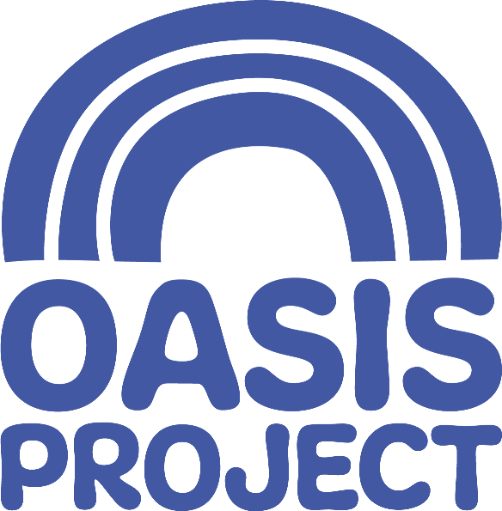

Equal Opportunities Monitoring Form (recruitment)

Which post are you applying for?
Where did yousee the post advertsed
(this helps us plan future job promotion)

What age are you? | ………………………………………..  □ I do not wish to disclose this
What gender are you? | □ Female □ Male □ Transgender  □ Other.................................................  □ I do not wish to disclose this information

How would you describe your ethnic origin?
Asian or Asian British  □ Bangladeshi  □ Indian  □ Pakistani  □ Chinese  □ Any other Asian  background  (please give details)  …………………………  Black or Black British  □ African  □ Caribbean  □ Any other Black  background  (please give details)  ………………………… | Mixed  □ Asian & White  □ Black African & White  □ Black Caribbean & White  □ Any other mixed  background  (please give details)  ………………………………  White  □ English/Welsh/Scottish/  Northern Irish/British  □ Irish  □ Gypsy or Irish Traveller  □ Any other White background  (please give details)  ……………………………… | Other Ethnic Group  - Arab  □ Any other ethnic group  (please give details)  ………………………………  □ Prefer not to say

Which of the following best describes your sexual orientation?
□ Heterosexual/Straight □ Lesbian/Gay woman □ Bisexual
□ Other (please state) …………………………………………………………..
□ Prefer not to say

What is your religion or belief?
□ I have no particular religion  □ Buddhist  □ Christian  □ Hindu  □ Jain | □ Pagan  □ Sikh  □ Agnostic  □ Atheist  □ Jewish  □ Muslim | □ Other (please state)  …………………………………..  □ Other philosophical belief  (please state)  …………………………………  □ Prefer not to say

Are your day-to-day activities limited because of a health problem or disability which has lasted, or is expected to last,  at least 12 months? |  | □ Yes a little  □ Yes a lot  □ No (do not answer the next question)  □ Prefer not to say
If you have more than one please tick all that apply. If none apply, please mark ’other’ and write an answer.

□ Physical Impairment □ Sensory Impairment □ Learning Disability/Difficulty
□ Long-standing illness □ Mental Health condition □ Autistic Spectrum
□ Other Developmental Condition
□ Other (please state) …………………………

Are you a carer?  A carer provides unpaid support to family or friends who are ill, frail, disabled or have mental health or substance misuse problems. | □ Yes  □ No  □ Prefer not to say
If yes, who do you care for? | □ Parent  □ Partner/spouse  □ Child with special needs  □ Friend  □ Other family member  □ Other (please give details)………………….
Armed Forces Service:  - Are you currently serving in the UK Armed Forces (this includes reservists or part-time service, eg: Territorial Army)?  - Have you ever served in the UK Armed Forces?  - Are you a member of a current or former serviceman or woman’s immediate family/household? | □ Yes □ No  □ Yes □ No  □ Yes □ No

Thank you for taking the time to complete this form.

This is sensitive personal data and will be treated with the utmost confidentiality in line with GDPR and the DPA 2018. The data will only be used for general statistical and monitoring purposes. In doing this, we are able to assess if we are effectively reaching out to diverse populations.

